Environmental Studies Program Internships
The Environmental Studies Program offers internships as one alternative to completing the capstone experience. This is an excellent opportunity to get real-world experience and form professional networks.

1. When are internships offered?
As needed in the Fall, Spring, and Summer sessions.

2. How do I plan for an internship?
You need to begin searching for an internship 1-2 semesters BEFORE you plan to intern. Spend some time doing research on internships in your area and around your interests (see below). When you have some ideas and you’re ready to plan, reach out to Dr. Mary Baker (mbaker@ric.edu) to set up a time to meet and talk more.

3. What are the requirements of the ENST internship?
Environmental Studies majors will complete

- 12-16 hours per week onsite per week during fall or spring terms if all coursework is conducted online.

- 10-14 hours per week onsite per week during fall or spring terms if students periodically meet on campus.

- an additional 2-4 hours per week online in coursework completing journal entries and both mid-term and end-of-term reports including development of a portfolio.

- Assigned readings may also be required.

Internships through
- Geography
- Political Science

may have different requirements. Please see the chairs of those departments.

List of organizations at which RIC students have completed internships:
- AS 220
- Center for Mediation and Collaboration Rhode Island
- Day One
- Girls on the Run
- Jewish Voice & Herald
- Learning For Life
- Museum of Work and Culture
- New Urban Arts Providence
- Office of Senator Jack Reed
- Progreso Latino
- Providence Media
- Rhode Island Coalition Against Domestic Violence
- Rhode Island Coalition for the Homeless
- Rhode Island Community Food Bank
- Rhode Island Historical Society
- Rhode Island Monthly Magazine
- Rhode Island Writing Project
- RI General Assembly
- RIC Adams Library
- RIC News and Communication
- RIC Writing Board
- RIPR
- Roger Williams Park Zoo
- Save the Bay
- Smith's Castle
- The Lippitt House
- The Writer's Circle
- United Way of Rhode Island
- Warwick Museum of Arts
- Waterfire
- www.easyeventplanning.com

- How do I find an internship?
- Internships can be completed through the Geography department.

Contact Dr. Mark Motte regarding this alternative. (mmotte@ric.edu)

- The Political Science Department offers two distinct semester-long internship courses that are connected with the ENST major.

Each course earns four academic credits. In addition to spending 120 hours on-site at the internship, students also meet weekly in a classroom setting to discuss their experience and put it in perspective internships.

http://www.ric.edu/politicalScience/internships.php

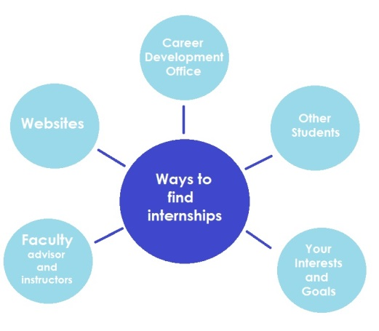

- Focus on your Interests and develop a plan: Think about what interests you, your strengths, and issues that matter to you. Make a short list and then reach out to us for help identifying an internship that aligns with your interests. Groups you might consider include:

- Audubon Society
- Clean Water Action
- Department of Environmental Management
- Environment Council of Rhode Island
- Environmental Justice League of Rhode Island
- Grassroots Global Justice Alliance
- Our Power Campaign
- Rhode Island Department of Health
- Rhode Island Food Policy Council
- Sierra Club, Rhode Island Chapter
- Toxics Action Center
- Woonasquatucket River Watershed Council

D. Search for internships in your local area:
- The Career Development Center lists many on-going internships at the DESTINATIONS web portal. https://www.ric.edu/careerdevelopment/fellowships.php

- Bridge.jobs is a website that connects Rhode Island employers with potential interns. Search their website for opportunities of interest to you.

